**What is an Ansible Role?**

An **Ansible role** is a way to organize your automation tasks, files, variables, and handlers into separate folders. This helps keep things clean, reusable, and easy to manage.

**Step 1: Create the Role Folder Structure**

You can create the role folder manually, but the easiest way is to use the command:



This command makes a folder named “myrole “with all the subfolders you need, like these:

* **tasks/** – where your main tasks go (like installing software)
* **handlers/** – actions triggered by tasks (like restarting services)
* **templates/** – configuration files with placeholders (like “nginx.conf.j2”)
* **files/** – static files to copy as-is
* **defaults/** – default variables for the role
* **vars/** – other variables
* **meta/** – info about the role

**Step 2: Write Your Tasks**

Open the file **“myrole/tasks/main.yml”** and add the instructions you want Ansible to run.

Example (install nginx, copy config, start service):

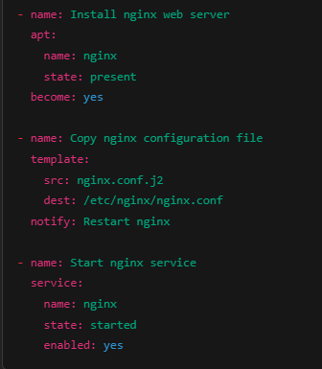

**Step 3: Define Handlers**

Handlers are tasks that run only if notified. For example, restarting nginx if the config changes.

Add this in “myrole/handlers/main.yml”:

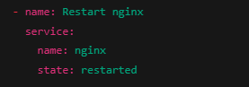

**Step 4: Add Templates or Files**

* Put any configuration files that need variables (placeholders) inside the
* “templates/ “folder.
* Put normal files that don’t change in the “files/” folder.

Example: Create “nginx.conf.j2 “inside” templates/ “with your nginx config and placeholders like “{{ nginx_port }}”.

**Step 5: Set Variables**

You can put variables that your role needs in:

* **“defaults/main.yml”** – default values anyone can override
* **“vars/main.yml”** – variables that are harder to override

Example **“defaults/main.yml**”:



Use “{{ nginx_port }}” inside your template to use this variable.

**Step 6: Use Your Role in a Playbook**

Create a playbook file (for example, site.yml) and tell Ansible to use your role:

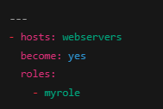

Run the playbook:

**“ansible-playbook -i inventory site.yml”**

**Summary:**

* Run ansible-galaxy init myrole to create role structure
* Write tasks in tasks/main.yml
* Add handlers in handlers/main.yml
* Put templates in templates/ and files in files/
* Define variables in defaults/main.yml
* Use role inside a playbook with roles: